Summary for pre-read

WBR - Summary (for Pre-Read)

1) DLD Market
The DLD Sale market continues its growth at 63% YoY, led by Primary (+90% YoY) and Secondary at +38% YoY. Excluding Land and >10M transactions, the market grew at 30% YoY with Primary at +54% YoY and Secondary flat at 0% YoY.

2) Commercial
Sales Forecast: AED 63.2M vs 63.5M target (99.5% achievement). Feb and March forecast currently at 95.7% and 92.7%
Net Exclusive Listings: 16K (target 23K); -3.2K MoM from 19.2K. Total Listings at 364.4K (+7.8K MoM).
ACTION: Team to speak with ELT decide on way forward for compliance and

3) Demand
Overall SoS: 57.8% (+6.6pp MoM), largely due to uplift in App SoS (64.4%. +11pp MoM) (BEING VALIDATED AS SPIKE IS QUITE HIGH)
Web SoS (48.4%) saw marginal decline of 0.5pp MoM
SEO SoS declined to 45.8% (1.4pp) and has not recovered from November (48.5% SoS)

Paid Web Funnel: Sessions saw a 5.8% YoY increase, while leads (298k, -2.5% YoY) and conversion rate (12.5%, -1.1pp YoY) remain largely stagnant
App Total Funnel: Sessions (2.7M) saw a decline of -5.9% YoY, while leads (663k, 7.9% YoY) and CR (24%, +3.1pp YoY) saw an increase
Leads Delivery: Total Leads Delivered 749K vs 708K target; Clicks to Delivered at 87.8% vs 83% target; Error Leads at 5.3% vs 4.9% target.
Exposure LPL: For Buy is 8.3 (vs 8.9 YoY), needs to be watched out in context client sentiment. Exposure LPL for Rent is stable at 14.9 (vs 14.8 YoY)

4) Data Governance: Direct, SEO, and App CRM data cleanup in progress; CHEQ spam implementation by Feb 24

5) New Projects (Primary)
Primary Plus revenue ($721.8k) at 125% of target
Media & Developers sales closed at 90% of target

6) B2C App
Android rating continues to be stable at 4.4 in Jan’25
App installs at 106k (+18% YoY) continue to grow
App MAU at 430k (+9% YoY) showing strong momentum
Click to delivered leads has improved to 87.8% (+6pp MoM)
B2C NPS at 3 (-9 MoM, -10 YoY). PR SoV at 71% (target 50-55%, -6.5pp MoM).

7) B2C Tech
CWV Mobile URLs have < 50% URLs marked as “Good”
Appdex Scores: iOS 95.6% (vs 95% target), Android 95.9% (vs 95% target)

8) B2B Performance
App active agents at 10,180 (+81 vs target of 10,099, +934 MoM).
WAU at 3,407 (+283 vs target of 3,124, +411 MoM).
Agent NPS baseline established at 64 (end-of-year target: 80).
Incident Volume: P0: 5 (vs 6 target), P1: 60 (vs 73 target).

9) Listing Quality
Compliance: 93% vs 87% target (+5pp above target, +1pp MoM).
Availability Perception: 80.6% vs 79% target (+1.6pp).
Listing Quality Score: 93.8 vs 93 target (+0.8 above target, +2.9 YoY).

Actions to be tracked
- Net Exclusive Listings below target - commercial and product initiatives needs accelerated execution for exclusive listings impact
- Mobile INP (Web Performance) red - optimizing 3rd-party tags; real-time INP tracking via RUMvision (ETA: End Q2)
- Data Governance - On time delivery of Spam removal mechanisms is required to track internal data effectively

DLD Market Growth

Property Finder
Weekly Business Review

Market (Dubai)
- The DLD Sale market continues its growth with the market growing at 63% YoY, largely led by Primary (+90% YoY) and secondary at +38% YoY
  - Within Primary - Offplan is the driver with 128% YoY Growth and Ready Primary showed +49% YoY
  - Within Secondary - Ready Secondary grew by 48% YoY while Off-plan Secondary de-grew at -9% YoY

- When we discard Land transactions and >10M transactions, the market still grew at 30% YoY. Primary Market is growing at +54% YoY, and Secondary market is flat (+0% YoY)
  - Offplan primary +107% YoY, Ready Primary -66% YoY
  - Offplan secondary -18% YoY, Ready Secondary is +7% YoY

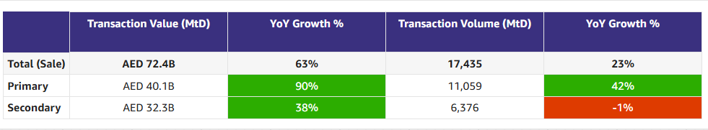

Commercial

Commercial
Category | DRI | Which metric is red and why | Actions planned | ETA for target achievement
Sales forecast % | Vladimir Malugin | Our sales was 99.5% for January | - Offers (launch of custom offers to incentivize higher % increases in contract value)  - Edge for Emerald launched  - Working closely with the Commercial Analytics team to have a clear narrative for all the key Diamond and Ruby Renewals
Client level Exclusive listing | Prateek Goel | - The movement in CLEL is largely driven by PF listings going offline and Bayut increasing CLEL. Common listings have stayed consistent  - Reason 1: PF CLEL going down by -2,059 (82,151 -> 80,092)  - PF decline is concentrated to top 10 clients contributing 82% of the movement. 2/10 are Edge clients  - There is no downgrade from these clients but 2 of them had minor (about 5-10%) decline credits received due to bonus/refund credits  - There is no impact from pricing action; Top contributor locations did not have a price is change  - Next Steps: Analyze if the listings were removed by the client or by our actions (e.g. LAT)  - Reason 2: Bayut CLEL going up by +1,162 (62,927 -> 64,089)  - Top 10 clients explain more than 100% of the gain  - 8 are common clients, while 2 are prospects (one is Bayut NB) -  - The gain is 60% on rent and 40% on sale, and 97% is Standard (which is more than their average exposure) -> Could be Bayut commercial action to increase supply for these select clients | Over the last 3 weeks, we’ve met multiple clients across Diamond, Ruby, and Sapphire, covering both API and Non-API agencies, to understand why exclusive supply is reducing  Three clear drivers emerged:  - Compliance mismatch: Some clients want to publish on PF but are blocked due to PF compliance, while Bayut allows the same listings. This makes the current baseline not apples-to-apples.  - Limited client awareness: Clients are often unaware that certain listings are missing on PF, exacerbated by workflow friction (notably the DLD Trakheesi permit process for Non-API clients).  - Bayut enablement: Bayut actively surfaces missing listings to clients via weekly updates and dedicated follow-ups, which drives parity.  Execution approach:  1. Fix the fundamentals: Align on compliance + duplication logic and rebaseline exclusive listings (BA + Product).  2. Enable visibility:  - Client-level exclusive listings to be surfaced in Sales Compass for BC-led conversations.  - A product-led solution to show clients which listings are live on Bayut but missing on PF (scalable vs BC-led). | - Awaiting rebaselined numbers

Monthly Metrics

 |  | MTD
Category | Metric | MtD  (Forecast) | Month (Target) | vs MtD  prev month (MoM) | vs competition | DRI | Dash
Sales  (MtD) - UAE | Sales Forecast %  (Month-end) | 62.9M  (99.5%) | 63.5M | Not Applicable | Not Applicable | Vladimir Malugin | Link
Supply | Net Exclusive Listings | 16K | 23k | -3.2K  19.2K | Not Applicable | Prateek Goel
 | Net Exclusive Listings  (Rent) | 4.3K | NA | -2.4K  6.7K | Not Applicable | Prateek Goel
 | Net Exclusive Listings  (Sale) | 11.7K | NA | -0.8K  12.5K | Not Applicable | Prateek Goel
 | Total Listings | 364.4K | NA | +7.8K  356.6K | -141K  505.4K
 | Total Listings  (Dubai) | 210.1K | NA | +2K  208.1K | -12.5K  222.5K
 | Total Listings  (Abu Dhabi) | 15.7K | NA | +0.8K  14.9K | +2K  13.7K
 | Total Listings  (Northern Emirates) | 138.6K | NA | +5.0K  133.6K | -130.6K  269.2K

Monthly Metrics

Category | Metric | Jan 2026 | Month (Target) | vs  prev month (MoM) | vs  prev year (YoY) | DRI | Dash
Sales | DXB Renewals - Diamond | 22.4 | 18.7 |  |  | Vladimir Malugin
 | DXB Renewals - Ruby | 5.8 | 6.4 |  |  | Adnan Erriade
 | DXB Renewals - Sapphire | 8.5 | 9.8
 | DXB Renewals - Emerald | 8.3 | 8.8 |  |  | Eoghan McCarthy
 | AUH Renewals | 4.0 | 4.1 |  |  | Mina Subhi
 | NE Renewals | 1.3 | 1.2 |  |  | Mina Subhi
 | New Business | 8.8 | 9.8 |  |  | Adnan Erriade
 | Upsells | 3.9 | 4.6 |  |  | Vladimir Malugin
Retention | Value Retention (%) - Overall | 114% | 112% | +21pp | +1pp | Vladimir Malugin
 | Value Retention - Diamond | 150% | 130% | +44pp | +9pp | Vladimir Malugin
 | Value Retention - Ruby | 110% | 108% | +13pp | -7pp | Adnan Erriade
 | Value Retention - Sapphire | 88% | 104% | +1pp | -14pp
 | Value Retention - Emerald | 93% | 95% | +8pp | +2pp | Eoghan McCarthy

Primary (NP, Media, Dev)

Primary (New Projects, Media Sales)
Category | DRI | Which metric is red and why | Actions planned | ETA for target achievement
New Projects | Enguerran Milhiet | - Closed the month at 107%¹  - Primary Plus revenue (credits consumed): 125%  - Media & Developers sales: 90% (see explanation below).  - Primary Plus overachiement driven by both:  - Volume (9% above target)  - Price: average selling price 15% above target driven by (i) change in project card ranking algorithm and (ii) commercial push to encourage clients to create more campaigns, leading to higher competition hence higher price.  - Sessions 2% below target. Expected back to green in February thanks to SEO initiatives and new performance marketing set up launched in January.  ¹While unorthodox in financial literature, I am adding Primary Plus revenue and Media sales to simplify the message.. | - Continue delivering the roadmap. Biggest contributor to meeting revenue target in Feb:  - Push adoption of open leads v2  - Pricing algorithm update. | - February expected on target.
Media & Developers | Sami Awada | - Pulled 2M AED deals from Jan to support Q4 2025 numbers.  - Repeat business is slow due to delivery | - Reduce backlog to support repeat business | - February forecast at 100%.

 |  | MTD
Category | Metric | MtD  (Actual) | Month  (Target) | vs MtD  prev month (MoM) | vs MtD  prev year (YoY) | vs competition | DRI | Dash
New Projects | Sessions | 377k | 385k | +13.7%  (was 331.5k) | -21.3%  (was 479.1k) |  | Enguerran Milhiet
 | Sold Leads | 8,585 | 7,910 | +11.9%  (was 7,670) | +118.2%  (was 3,935) |  | Enguerran Milhiet
 | Gross Revenue (USD) | $721.8k | $578k | +11.3%  (was $648.5k) | +158.7%  (was $279k) |  | Enguerran Milhiet
Media & Developer | Revenue from Media Products | $553k (90%) | $610k | NA | +59% |  | Sami Awada

Demand (Paid/Unpaid)

Demand
Category | DRI | Which metric is red and why | Actions planned | ETA for target achievement
Paid | Ahmed Osman | - Paid Web Listing Leads: Lower than the target by 2%.  - Paid Non-Listing web leads have increased massively MoM and are now at an all-time high.  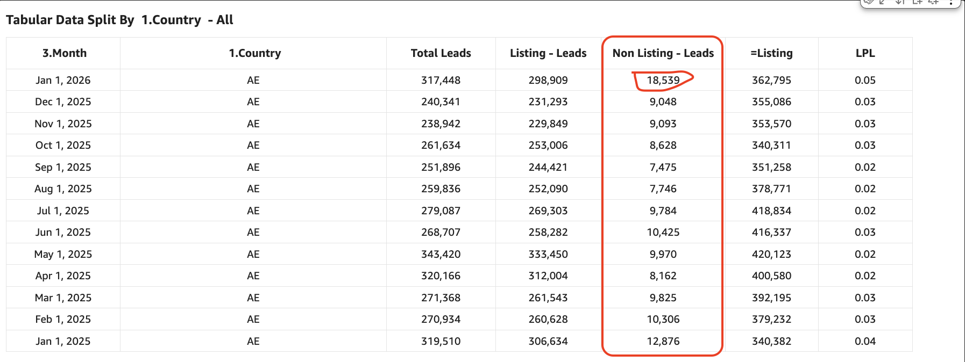 | - BA to analyze the reasons for the surge in non-listing leads coming from paid search.  - Hypothesis #1: Increased non-listing leads are a result of the SuperAgent Carousel cards on SERPs. (Disproved)  - Hypothesis #2: Data tracking issues affecting the classification of leads. [JIRA Ticket] | - Feb, 2026
Unpaid - SEO | Mahmoud Nessim | Desktop Success vs. Mobile Gap  - Desktop SimilarWeb: 52% SoS (all-time high)  - Total SimilarWeb: Fell short due to mobile traffic underperformance (Can be explained by Web to App attribution, especially as we’re at all time high App )  Residential Buy vs. Rent Performance Split  - Residential Sale: 60% SoS (all-time high, massively exceeded expectations)  - Residential Rent: ~ 42% SoS (significant MoM growth but didn't outpace Bayut)  Root Causes - overall and specifically Rental Category Structural Issues:  - Mobile tracking discrepancy: Mweb deeplinks redirect to app, which SimilarWeb doesn't capture. Rental users inherently have higher activity rates than buyers, amplifying this blind spot.  - Product /listings quality & quantity deficits in rentals:  - High listing duplication rates* ( Yet to be investigated )  - Dubizzle and Bayut dominate absolute listing numbers  - Performance marketing and direct traffic severely underperforming  - Zero listings in communities where competitors rank organically  - Competitors' organic growth compounds as they strengthen presence in high-inventory areas, and amplified by some KWs we don’t even have Paid search ads on.  - Measurement infrastructure gaps: Current tracking capabilities insufficient for accurate performance assessment | Immediate  - Initiate critical stakeholder conversations on rental category performance gaps ( Done, and pushed by Fernando with the team )  - Escalate tracking improvements from "nice-to-have" to mandatory requirement ( WIP )  - Confirm SimilarWeb mobile measurement methodology with vendor team  Short to mid-term  - Continue content acceleration in Residential Sale (proven 60% SoS model)  - Develop rental category recovery roadmap addressing:  - Listing quality and deduplication  - Community coverage gaps  - Performance marketing Pushes ( Already started and waits some analysis )  - Organic ranking strategy for underserved areas, with UGC, translations, content growth, internal linking which is part of Q1 roadmap  Foundational  - Implement comprehensive mobile traffic attribution system  - Establish rental-specific KPI dashboard with accurate channel attribution | - Supply & Demand correlation dashboard to be done by this week.  - Rest of SEO initiatives are BAU with the planned Q1 roadmap.  - Mobile tracking as part of the data governance.
Unpaid - Overall | Soumar Aoun | - No formal metrics to report yet on unpaid web (spam to be removed by 24th Feb) | CRM – WBR Highlights  - CRM sessions are ahead of target: we should be at 186K, and we are at 215K (+29K / +16% above plan). Since the 100% rollout of AI-powered Search Re-engagement, daily CRM App Sessions increased from ~5K/day → ~9K/day, reinforcing the AI-led approach.  - Delivery in progress: WhatsApp Login (Web & App), Community Insights Push Re-engagement (App), Search Re-engagement Email Revamp (Web), Valuation Change Email (Web), and Post-Lead Pillar – CRM 2.0 (partial scope, App).  Next sprint priorities: Blogs on App, Exploration Pillar – CRM 2.0, Travel Times & My Activity visibility (Email/Push/In-App), Web & App modals design uplift, and Create Alert + Saved Property email revamp (Web).  App & Web – Product Momentum  - AI Search UI uplift (App) shipped to 100%: clearer toggle visibility, Inspiration removed, Recent Searches added, and softer error messaging.  - App Homepage in development to drive higher sessions and conversion.  - Web SERP Revamp expected to go live in the next 2 weeks.  - Travel Time launched 100% on App + Web (Feb 4) with early positive CR signals (data pending).  - Navigation launched 100%, increasing sessions from 2.3K → 4K monthly (CR impact pending). | Mentioned in action planned.

1. Competition
- Share of Session (Overall, Web Channels, App Channels)
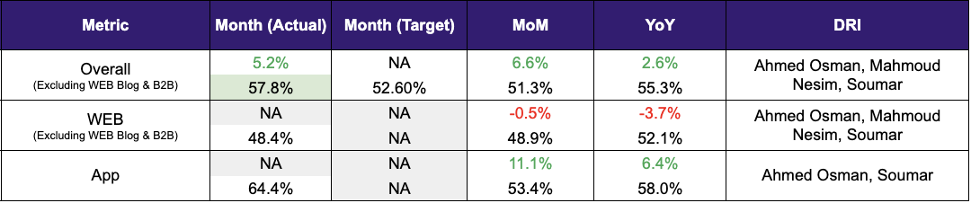

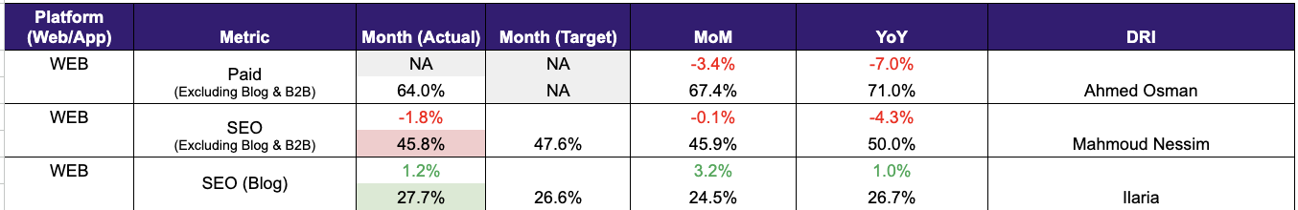

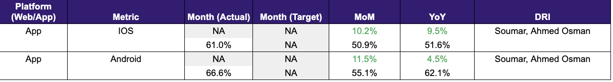

- SEO SoV - Paid click share

Metric | MtD (Actual) | MtD (Target) | MtD PM | vs MtD PM | DRI
Paid click share | 36.4% | NA | 41.9% | -5.5% | Ahmed Osman
SEO SoV | 41.6% | NA | 39.7% | 1.9% | Mahmoud Nessim

2. Demand Funnel
(Direct and SEO Data are currently being fixed under Data Governance Workstream)

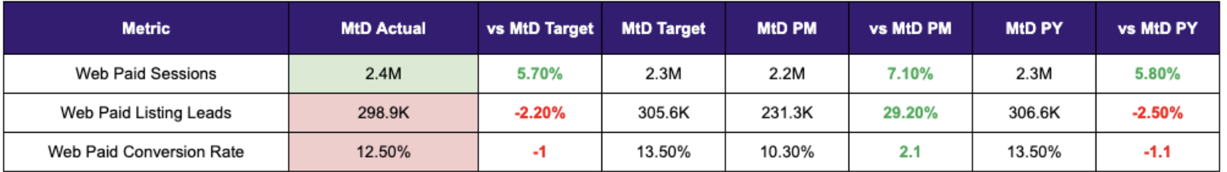

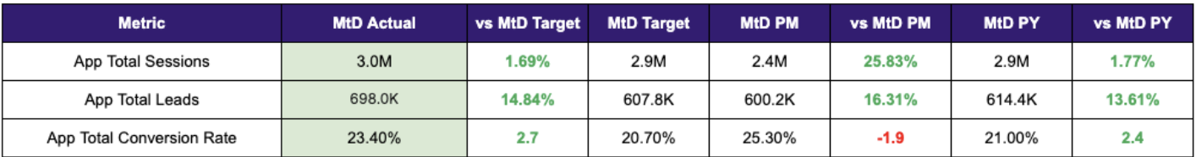

Exposure LPL (EXCLUDES DIRECT - Both in targets and actuals)
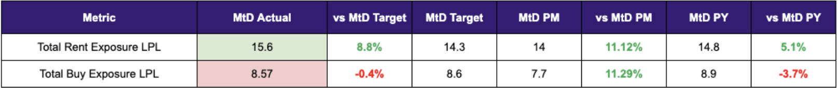

Leads and Listings distribution
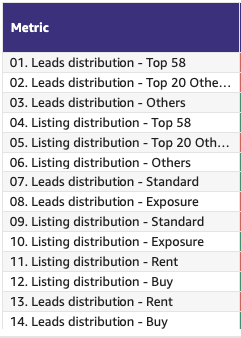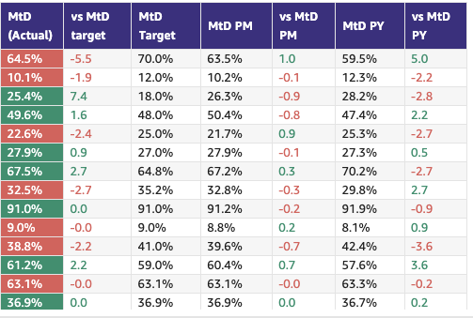

Leads click to delivered:
Category | Metric | MtD  (Actual) | Month (Target) | vs MtD  prev month (MoM) | vs MtD  prev year (YoY) | Δ vs Competition | DRI | Dash
Leads Funnel | Total Leads Delivered (WA) | 749k | 708k | 582k | 641k | Not Available | Olivia Watters | Link
 | % Clicks to Delivered (WA) | 87.8% | 83% | 81.7% | 85.6% | Not Available | Olivia Watters | Link
 | Error Leads (WA) | 5.3% | 4.9% | 5.5% | 7.6% | Not Available | Olivia Watters | Link

Rent vs Buy Split

Monthly Metrics

Time on Site
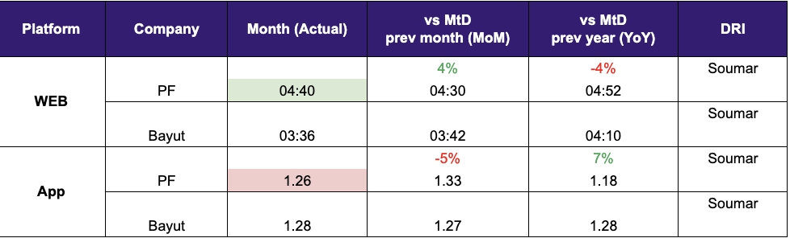

B2C NPS
Category | Metric | MtD  (Actual) | Month (Target) | vs MtD  prev month (MoM) | vs MtD  prev year (YoY) | vs competition | DRI | Dash
B2C NPS | B2C NPS | 3 | Not Available | -9  12 | -10  13 | Not Available | Alson Dsouza

PR Metric
Category | Metric | MtD  (Actual) | Month (Target) | vs MtD  prev month (MoM) | vs MtD  prev year (YoY) | vs competition | DRI | Dash
PR | PR Sov | 71% | 50-55% | -6.5 pp  78.5% |  | 26.1% (Bayut) and 2.9% (Dubizzle) | Natalie Faulkner | PR team

- Competition
  - Share of Session (Overall, Web Channels, App Channels)
  - SoV - Paid click share

- Demand Funnel
  - Sessions (by channels)
  - Leads (by channels)
  - CR (by channels)
  - Click to Delivered

- Exposure LPL
  - Overall / Rent / Sale
  - Top Communities
  - Web/App
  - Exposure Leads as % of Total Leads (Overall / rent / sale)
  - Exposure Listings (Overall / rent / sale)

- Engagement Metric (Time on site)

- B2C NPS
- PR SoV
- Leads split by Rent vs Buy

Data Governance

DATA GOVERNANCE
Data Issue | Latest update | Resolution update (ETA) | DRI
Spam Issues | Front-end implementation is complete and we are waiting for the Data Engineering team to finish the backfilling and set up future reporting. | Current & past data resolution by 24th Feb | Ram Moorthy
SEO (Sessions vs clicks) | Under last-touch attribution, repeat or direct returns get credited to SEO, so SEO sessions appear higher than GSC clicks. | Resolved - Aligned that higher SEO sessions are expected due to the last-touch non-direct attribution model, where repeat direct visits are still attributed to SEO; this analysis is validated by Mahmoud and Valkon.  Spam implementation with backfill will complete by Feb 24, after which the SEO team will report SEO sessions; mobile SEO attribution will be reviewed offline as a non-blocker. | Ram Moorthy  Volkan Oktem
CRM Attribution Reporting | Wael Abdella is doing the root cause analysis by working with all the stakeholders. | Mar 2 | Ram Moorthy
Kochava Usage Assessment and Cost Optimisation | Mahesh Maheswaran Has started gathering all the data needed for the discovery phase. | TBD | Ram Moorthy

B2C App Engagement

B2C App
Category | DRI | Which metric is red and why | Actions planned | ETA for target achievement
App engagement & installs | Ahmed Osman | - N/A. Strong traction on both acquisition and engagement metrics on the app. With a bigger opportunity for growth on Android. | - Planned activities for the remainder of Q1, focused on more diversified messaging (HV, My Activities, New Simplified UI, Travel Time). | - Consider reviewing MAU targets to reflect a potential YoY increase.
App ratings | Soumar Aoun | - Green N/A | - Green N/A | - Green N/A

Weekly Metrics -

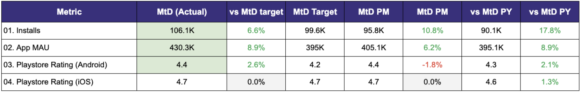

- App Installs
- App MAU
- DAU/MAU
- Sessions / DAU
- Login Ratio
- Avg Session Duration
- Playstore rating (Android)
- Playstore rating (iOS)\

B2C Tech Metrics

B2C App
Category | DRI | Which metric is red and why | Actions planned | ETA for target achievement
App stability & performance | Taran Kambow
Web Stability & Performance | Amory Kelie | - Mobile Interaction to Next Paint (INP) is red.Trending +8.7pp up because of some minor js improvements | - Optimize 3rd-party tags.  - Implement real-time INP tracking via RUMvision. | - End of Q2

 |  | MTD
Category | Metric | MtD | Month (Target) | vs MtD  prev month (MoM) | vs MtD  prev year (YoY) | vs competition | DRI | Dash
Growth | CWV % URLs rated “Good” | Mobile: 39% | Desktop: 65% | Mobile > 50% | Mobile: +8.7pp |  |  | Amory Kelie
 | Appdex (Android)* | 95.9% | +0.9pp  95% | -0.1pp  96% |  |  | Taran Kambow
Tech stability & Performance
 | Appdex (iOS)* | 95.6% | +0.6pp  95% | -0.5pp  96.1% |  |  | Taran Kambow

- Appdex: Android
- Appdex score: iOS

B2B Product

B2B
Category | DRI | Which metric is red and why | Actions planned | ETA for target achievement
CSAT (P0s) | Luis Cappa | Exit Jan in Green.
Agent Experience | Sajjad Ahmad | Exit Jan in Green.

Weekly Metrics
 |  | MTD
Category | Metric | MtD  (Actual) | Month (Target) | vs MtD  prev month (MoM) | vs MtD  prev year (YoY) | vs competition | DRI | Dash
CSAT | Incident Volume | P0: 5  P1: 60 | P0: 6  P1: 73 | P0: +5 (0)  P1: +3 (57) | P0: +2 (4)  P1: -13 (73) | Not Available | Luis Cappa | Link  (JIRA)
 | Agency NPS** | 64 |  |  |  |  | Person
Agent Engagement | App active agents | 10,180 | +81  (vs 10,099) | +934  (vs 9246) | Not Available | Not Available | Sajjad Ahmad | Link
 | Active users per week (WAU) | 3407 | +283  (vs 3124) | +411  (vs 2996) | Not Available | Not Available | Sajjad Ahmad
 | Agent NPS** | 64 | 64 | - |  |  | Sajjad Ahmad | Link to report

** Note: Agent NPS was measured for the first time in Jan’26 to establish a baseline. The end-of-year target is 80. Performance tracking against this benchmark will commence from next month onward.

Listing Quality

Monetization
Category | DRI | Which metric is red and why | Actions planned | ETA for target achievement
Compliance | Saif Al-Amid | - Enforced compliance metrics are stable | - For fake listings (an overlapping topic); a plan has been prepared to tackle some of the underlying causes. | - Please find here the project plan for fake listings.
Availability perception | Shradha Mohanan | - Green | - Revised model development & validation underway. Accessing impact of agent responsiveness on availability perception.

 |  | MTD
Category | Metric | MtD  (Actual) | Month (Target) | vs MtD  prev month (MoM) | vs MtD  prev year (YoY) | vs competition | DRI | Dash
Listing Quality | Compliance % | 93% | +5pp  87% | +1pp  92% | NA | Not Applicable | Saif Al-Amid | Link
Perceived Quality | Availability Perception (%) | 80.6% | +1.6pp  79% | +1.1pp  79.5% | +6.8pp  73.9% | Not Applicable | Shradha Mohanan | Link
Listing Quality | Listing Quality Score | 93.8 | +0.8  93 | +0.4  93.4 | +2.9  90.9 | Not Applicable | Huguette Bukasa | Link

Special Projects
Monthly Lookbacks

Special Projects - Q1 OKRs
Keyper Soumar Aoun Status
  - Minimum 90% - by end of Q1- (10% is a realistic buffer for any integration and unseen problems)
  - The Integration of the phased development from both team : (1) Keyper will deliver components by sequence and we will be integrating those within our systems
  - Nothing is delaying process for now
  - Proactive risk monitoring through frequent syncs with Keyper. Joint QA resourcing planned for mid-March integration phase to ensure schedule adherence.

Bundles Paresh Goyal On Track
- On track to onboard 15 clients on bundles by the end of the quarter as per the OKR
- Product requirements and the designs locked and reviewed by all stakeholders. Product development in progress as per the plan
- No blockers at the moment
- Validation and pre-sales ongoing: 30 clients have been shortlisted for this phase and the meetings are currently underway

Converting at risk clients to Promoters Ivan Gregorc Status
- Expected achievement at the end of the quarter. Based on current progress, what’s the estimated achievement rate for the end of Q1 2025?

- Achievement (till date) : Indicate completed and pending tasks.

- Impediments : If applicable, what is delaying the progress?

- Initiatives to address impediments: What actions will we take to address the above issues or improve results?

North Stars

 |  | Month
Category | Metric | MtD  (Actual) | Month  (Target) | vs MtD  prev month (MoM) | vs MtD  prev year (YoY) | DRI
Output metric | Share of Wallet | 54.8%  (Dec 2025) | NA | -0.2pp | NA | Vladimir Malugin
North Star Metric | Share of Sessions | 57.8%  (Jan 2026) | 52.6% | +6.6pp  51.3% | +2.6pp  55.3% | Soumar AounAhmed OsmanMahmoud Nessim
North Star Metric | Net Exclusive Listings | 16k | 23k | -3.2K  19.2K | NA | Prateek Goel

Exposure LPL (EXCLUDES DIRECT - Both in targets and actuals)
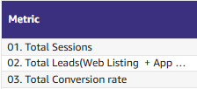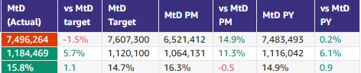
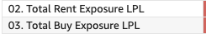

📋 Prev Saved Reports

Week | Date | Link
Week 4 | Jan 19 to Jan 25 | WBR - Week 4 (Saved) Metric Report
Week 3 | Jan 12 to Jan 18 | WBR - Week 3 (SAVED) Metric Report
Week 2 | Jan 5 to Jan 11 | WBR - Week 2 (SAVED) Metric Report
Year End.
W52 | Dec 1 to Dec 30 | WBR Metric Report - Dec Monthly Lookback (Saved Report)
W49 | Dec 1 to Dec 7 | WBR Metric Report - Week 49 (Saved Report)
W48 | Nov 1 to Nov 30 | WBR Metric Report - Week 48 - Nov Monthly Lookback (Saved Report)
W47 | Nov 17 to Nov 23 | WBR Metric Report - Week 47 (Saved Report)
W46 | Nov 10 to Nov 16 | WBR Metric Report - Week 46 (Saved Report)
W45 | Nov 3 to Nov 9 | WBR Metric Report - Week 45 (Saved Report)
W44 | NA | NA
W43 | Oct 1 to Oct 31 | WBR Metric Report - Week 43 - Oct Monthly Lookback (Saved Report))
W42 | Oct 15 to Oct 21 | WBR Metric Report - Week 42 (Saved Report)
W41 | Oct 8 to Oct 14 | WBR Metric Report - Week 41 (Saved Report)
W40 | Oct 1 to Oct 7 | WBR Metric Report - Week 40 (Saved Report)
W39 | Sep 1 to Sep 30 | WBR Metric Report - Week 39 (Saved Report)
W38 | Sep 17 to Sep 23 | WBR 2.0 Report - Week 38 (Saved Report)
W37 | Sep 10 to Sep 16 | WBR 2.0 Report - Week 37 (Saved Report)
W36 | Sep 3 to Sep 9 | WBR 2.0 Report - Week 36
W35 | Aug 1 to Aug 31 | Copy of WBR 2.0 Report - Week 35.docx
W34 | Aug 20 to Aug 26 | Copy of WBR 2.0 Report - Week 34.docx
W33 | Aug 13 to Aug 19 | WBR 2.0 Report - Week 33.docx
W32 | Aug 6 to Aug 12 | Copy of WBR 2.0 Report - Week 32.docx
W31 | Jul 30 to Aug 5 | WBR 2.0 Report - Week 31.docx

